Name(s) of author(s)
Brief Instructions on Writing an Essay/Dissertation (Name of the Work)

Name of the teacher
Course name
7.10.2020

Contents
1 Introduction 1
1.1 Description of essay/dissertation structure 1
1.2 Aim 2
1.3 Layout 2
2 Structure 4
Sources 5

Appendices

Introduction
Write a brief introductory text between the heading and sub-heading.

Description of essay/dissertation structure
Project studies and other courses at KAMK often involve essays/dissertations concerning the theoretical background of a given topic. Table 1 presents essay structure 1 and table 2 essay structure 2.
The structure of an essay is:
1 Introduction | (Objectives of the essay = its benefits, purpose = what was done, examined, developed, possible background and delineation)
2 Theory | (Heading that describes the content)  The theory part can be divided into sub-sections. If you use sub-headings, you need at least two of them (e.g., 2.1 and 2.2, etc.)
3 Discussion | Discuss the content and conclusions in your own words as well as what you learned from your work.
Table 1. Structural model of an essay 1
An essay can also be structured:
1 Introduction | (Objectives of the essay = its benefits, purpose = what was done, examined, developed, possible background and de-lineation)
2 Theory | (Heading that describes the content)  The theory part can be divided into sub-sections. If you use sub-headings, you need at least two of them (e.g., 2.1 and 2.2, etc.)
3 Documentation of practical development activities | (Heading that describes the content)
4 Discussion | Discuss the content and conclusions in your own words as well as what you learned from your work.
Table 2. Structural model of an essay 2

Aim
The aim of an essay or dissertation (long essay) is to examine a topic or topics related to a project or other learning assignment in detail and to compile a clear, cohesive, and logically organized textual representation concerning the topic(s). The topic(s) should be delineated to enable students to gain in-depth knowledge of the theoretical knowledge related to the topic. The purpose is also to help students discover and express their own perspectives regarding the project or learning assignment – in other words it is not necessary to consider/reflect upon everything that occurred during the project from a theoretical point of view. The course teacher and students will agree on how the topic(s) will be approached. The style of the text is discursive which means you can include personal material in the essay as well as theory.

Layout
The essay must include a title or cover page that displays the name of the author(s) and the title of the work that describes the topic, the name of the course teacher or supervisor of the essay, the name of the course or the project and the date of submission (due date). The instructions for the layout of the text in this essay template and the source references etc. are the same as for the KAMK thesis where applicable.
The instructions can be found at
https://www.kamk.fi/en/Students/Thesis

Source referencing also known as citation is used in the text and the sources are listed by reference in alphabetical order in the list of sources at the end of the essay. The APA 6 referencing/citation system is used at KAMK (apart from in Engineering, where the Vancouver system is used). For more instructions and examples, please see KAMK library’s website: https://libguides.kamk.fi/c.php?g=652742
Extra information on citation – see the left-hand column for examples:
https://owl.purdue.edu/owl/research_and_citation/apa6_style/apa_formatting_and_style_guide/general_format.html
An in-text source reference or citation means that the author, year of publication and page number(s) of a source is given in the text when the source has been used in the essay. The list of references includes the author(s), year of publication, the name of the publication, the publisher or URL. When internet pages are cited, the listed source also includes the date when the source was accessed/seen/used.
The source reference is marked clearly in brackets after the text being used as a source. The http address is never given as a source reference within the text. If the referenced text includes more than one sentence, the full-stop comes at the end of the final sentence before the reference.
  - The company needs a vision that motivates employees. Vision must override narrow business goals. (Wilenius, 2016, 155)
In the case of single sentences based on a source, the full stop is placed after the source reference.
Referenced text (Heponiemi, Wahlström, Elovainio, Sinervo, Aalto & Keskimäki 2008, 23).
Internet sources are also written in the same way as printed sources (author or organization) without the http address. The citation should include the name(s) of the author(s), but if unknown, the first couple of words of the title of the website can be given or the name of the organization that produced the website.
Referenced text. Referenced text. (Employment increased, 2017)
Referenced text. Referenced text. (Statistics Finland, 2017)
Be sure to check that your source references are clearly marked so that it is possible to differentiated between your own and somebody else´s ideas and work.
Appendix 2 contains examples of how to label and include tables and pictures in your essay.
The essay is written as a coherent, structured presentation that begins with an introduction and ends with the discussion. The language of the essay must meet the basic requirements of academic English.
The introduction briefly and interestingly explains the starting points and background of the essay. It describes the goals (why is the work done?) and the purpose (what is being processed / done?) and delimits what will be discussed in more detail based on the theory. One purpose of the introduction is to sell the work to the reader and answer the question of why the reader should read the essay.
The theoretical part examines the theory related to a limited topic in a structured way. The essay can include observations of action in practice - focusing on the chosen perspective. Head the section(s) so that the headings describe the content of the section.
Finally, the discussion section focuses on your conclusions and an assessment of them and your own ideas. The discussion should be entirely your own text without paraphrased source material and direct citation. A good essay deals with the learning assignment, reflecting upon its theoretical background - considering the causes, consequences and what was learned. The introduction “makes promises about the future” and the reflection “makes these promises come true”.
Appendix 1 presents helpful questions that you can use as you think about the contents of the various sections in your essay.

Sources
Hirsjärvi, S., Remes, P. & Sajavaara, P. (2009). Tutki ja kirjoita. Helsinki: Tammi.
Korpela, J. (2012). Kirjoita asiaa. Arkisen asiakirjoittamisen opas. Luettu 7.10.2015. https://www.cs.tut.fi/~jkorpela/kirj/
Vuokola, J. (2015). Tarkkana pilkun paikasta. Talouselämä 14/2015. 51 - 53.

Appendix 1. Structural mod
The main sections/headings of your essay | What should I include? | Useful questions and recommendations that can help you decide how to write your essay/dissertation.
1 Introduction | You must first introduce your research or development topic to the reader. You need to keep in mind that the reader may not be familiar with the topic, or they may not know why it is important to you. Therefore, your first task is to explain what you have researched or developed, what your view of the topic in hand and why you are interested in it.  In the introduction, you should tell the reader what problem/development target you have researched/ developed. Try to explain the problem, issue, or development target that you were analysing and contemplating. | What am I researching/developing? What is the purpose of my research/development work? What is the problem/development target that the research/project aims to solve? Why is this item important or significant to you and/ or the client?
2 Theory | In the theory section, you need to write the essentials about the theory you have used in your problem solving or development work. The theory is limited to the perspective your chosen perspective.  Theory is like "glasses" through which reality appears sharper and different. | What issues affect(ed) problem-solving?  What issues affect(ed) the success of a project?  What do/did the sources say about this problem / development target?
3 Discussion, learning something new | Explain to your readers what you discovered about your topic during the project. Did you succeed in gaining in-depth expertise by using theoretical knowledge? | What did you find out?  What new questions arose?  What kind of you understand now that you didn’t understand at the beginning of the project
Sources | Example  Hirsjärvi, S., Remes, P. & Sajavaara, P. (2009). Tutki ja kirjoita. Helsinki: Tammi.  Korpela, J. (2012). Kirjoita asiaa. Arkisen asiakirjoittamisen opas. Seen 7.10.2015. https://www.cs.tut.fi/~jkorpela/kirj/  Vuokola, J. (2015). Tarkkana pilkun paikasta. Talouselämä 14/2015. 51 - 53. | Lukija on kiinnostunut siitä,  The reader is interested in  WHO is your source – remember to critically evaluate your sources! - The http address is just a distribution channel.  Other sources in the same style  Who. When. What. Where. (publisher, http)

Appendix 2. Tables and figures
Number all tables sequentially as you refer to them in the text (Table 1, Table 2, etc.), likewise for figures (Figure 1, Figure 2, etc.). Remember, if the tables/figures are taken from other sources, give the source reference.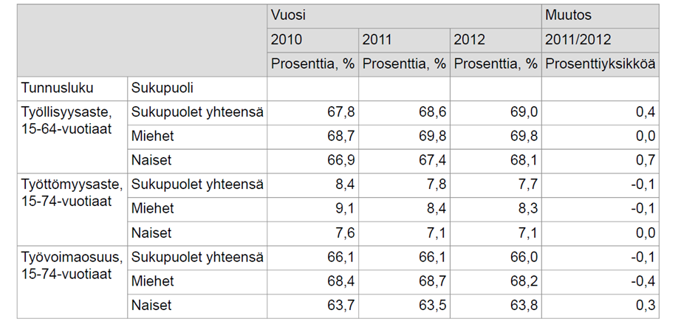
Table 1. Työllisyys- ja työttömyysaste, työvoimaosuus 2010 - 2012 (Työllisyysasteen kehitys, 2013)
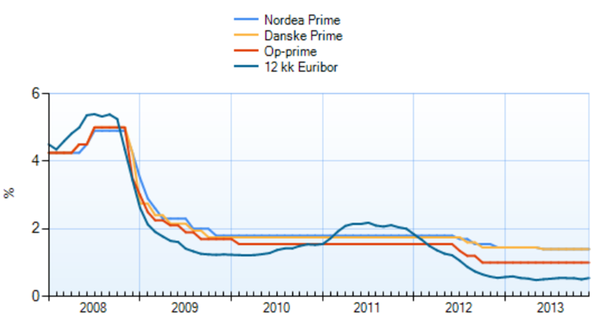
Figure 1. Suomen talletuspankkien viitekorkoja ja 12 kk euribor (Viitekorkojen kehitys, 2014)

